**MINOR PROJECT SYNOPSIS ON THE NAVIGATION OF THREE SCREEN USING PUSH AND POP**

**PROBLEM STATEMENT:**

This is an app where the user can navigate the screen the screen using push and pop navigator method

**OBJECTIVE:**

* The user can navigate the screen as for requirement.

**ABSTRACT:**

This app allow the user to navigate the screen . The user can move from one screen to another screen by using push and pop navigator method.

**DESCRIPTION OF THE PROJECT:**

* **CODE OF THE PROGRAM:**

**import 'package:flutter/material.dart';**

**void main() {**

**runApp(const MaterialApp(**

**title: 'Navigation Basics',**

**home: FirstRoute(),**

**));**

**class FirstRoute extends StatelessWidget {**

**const FirstRoute({Key? key}) : super(key: key);**

**@override**

**Widget build(BuildContext context) {**

**return Scaffold(**

**appBar: AppBar(**

**title: const Text('First Route'),**

**),**

**body: Center(**

**child: ElevatedButton(**

**child: const Text(' Go to next screen'),**

**onPressed: () {**

**Navigator.push(**

**context,**

**MaterialPageRoute(builder: (context) => const SecondRoute()),**

**);**

**},**

**),**

**),**

**);**

**}**

**}**

**class SecondRoute extends StatelessWidget {**

**const SecondRoute({Key? key}) : super(key: key);**

**@override**

**Widget build(BuildContext context) {**

**return Scaffold(**

**appBar: AppBar(**

**title: const Text('Second Route'),**

**),**

**body: Center(**

**child: ElevatedButton(**

**child: const Text('go to next screen'),**

**onPressed: () {**

**Navigator.push(**

**context,**

**MaterialPageRoute(builder: (context) => const ThirdRoute()),**

**);**

**},**

**),**

**),**

**);**

**}**

**}**

**class ThirdRoute extends StatelessWidget {**

**const ThirdRoute({Key? key}) : super(key: key);**

**@override**

**Widget build(BuildContext context) {**

**return Scaffold(**

**appBar: AppBar(**

**title: const Text('Third Route'),**

**),**

**body: Center(**

**child: ElevatedButton(**

**onPressed: () {**

**Navigator.pop(context);**

**Navigator.pop(context);**

**},**

**child: const Text('Go back!'),**

**),**

**),**

**);**

**}**

**}**

* **Description of working of project with help of snap of output:**

This is first screen of an app ,where the the user has to click button which contain the text go to next screen. By clicking that button the app go to next screen ie sceond route(screen) . The method is used push operation.

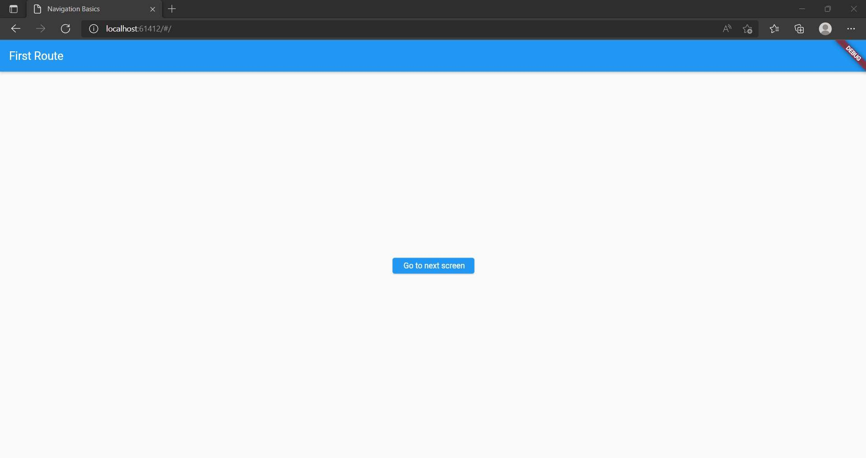

This is second screen of an app ,where the the user has to click button which contain the text go to next screen. By clicking that button the app go to next screen ie third route(screen) . The method is used push operation.

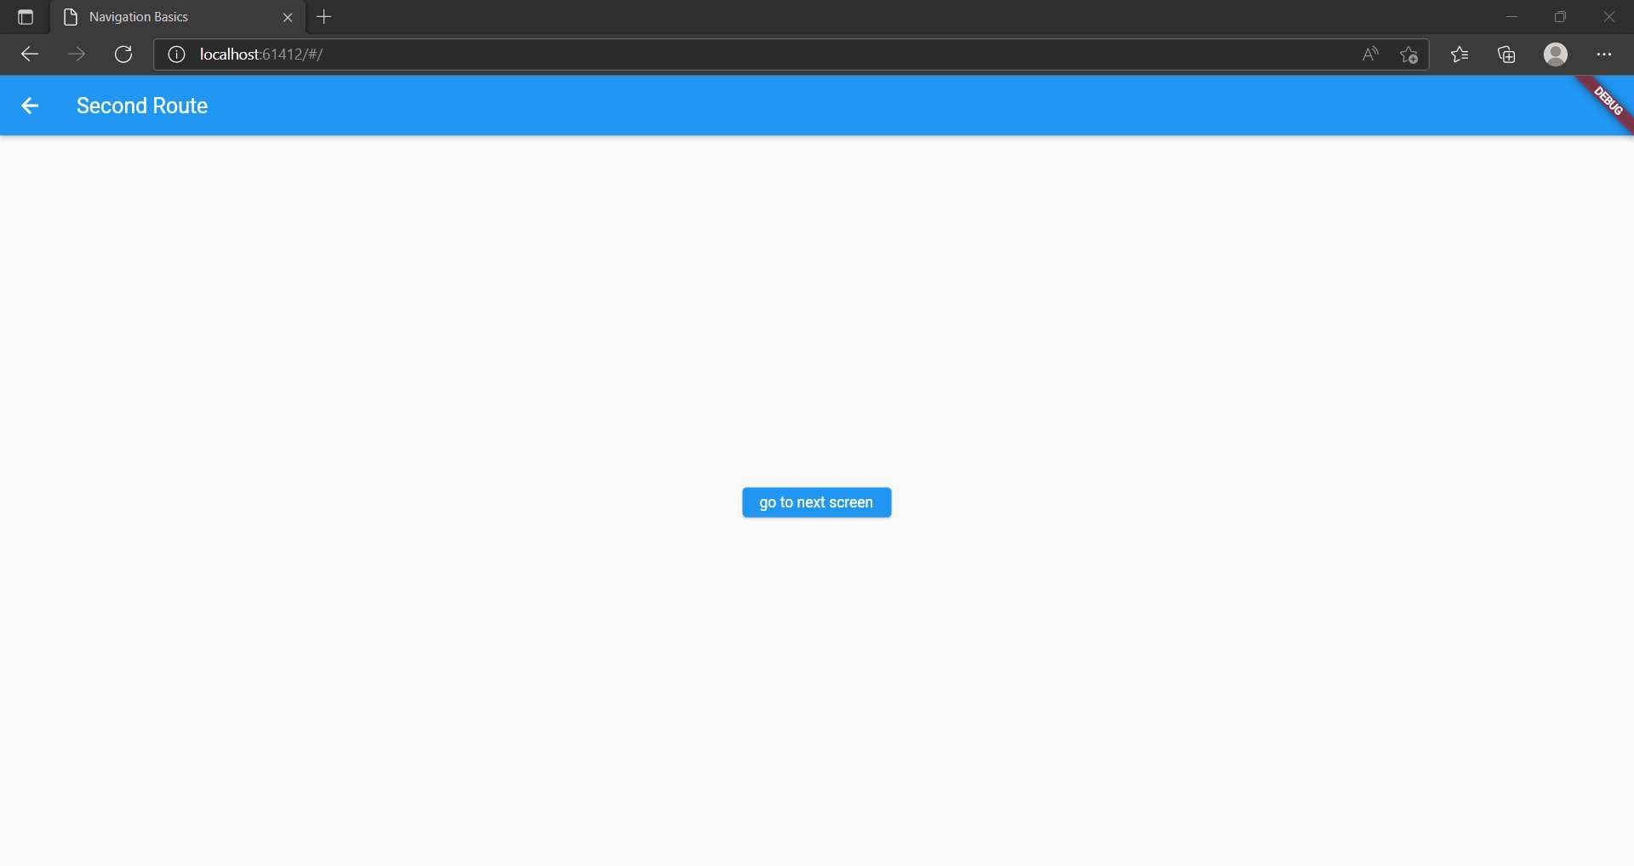

This is third screen of an app ,where the the user enter to last screen of the app.

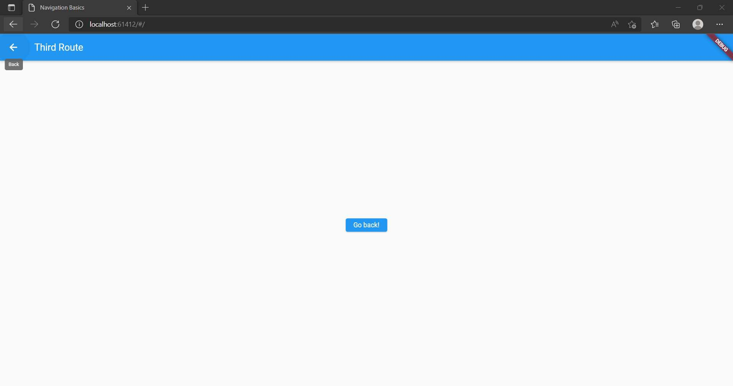

This is first screen of an app ,where the the user has to come to the first screen by using the pop method

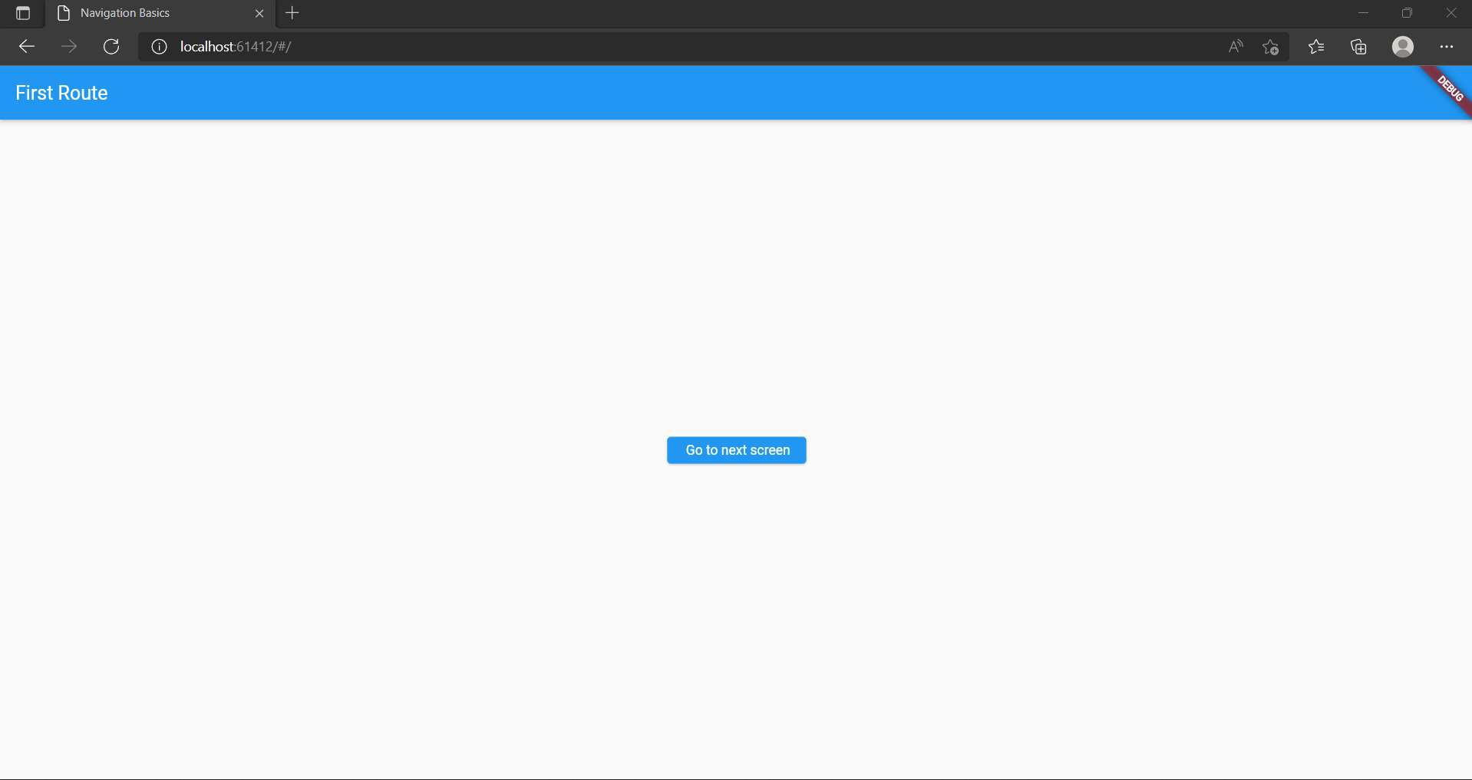

* **CODE SCREEN SHORT:**

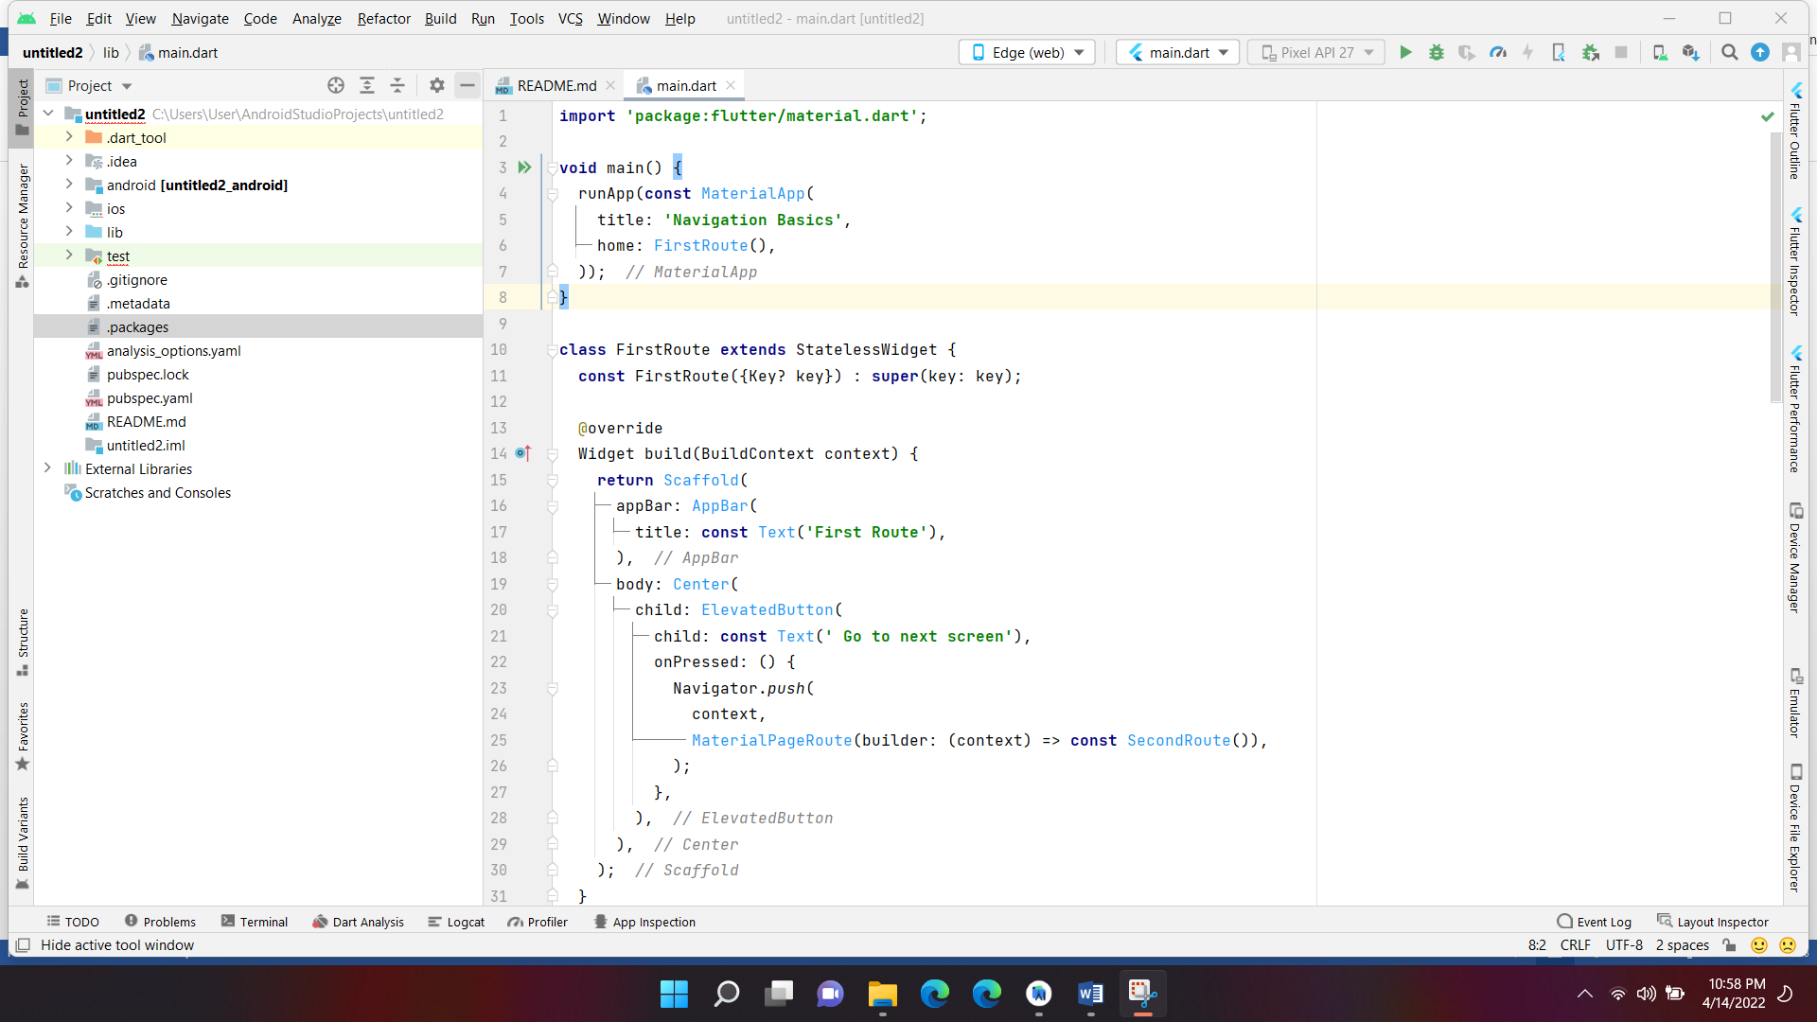

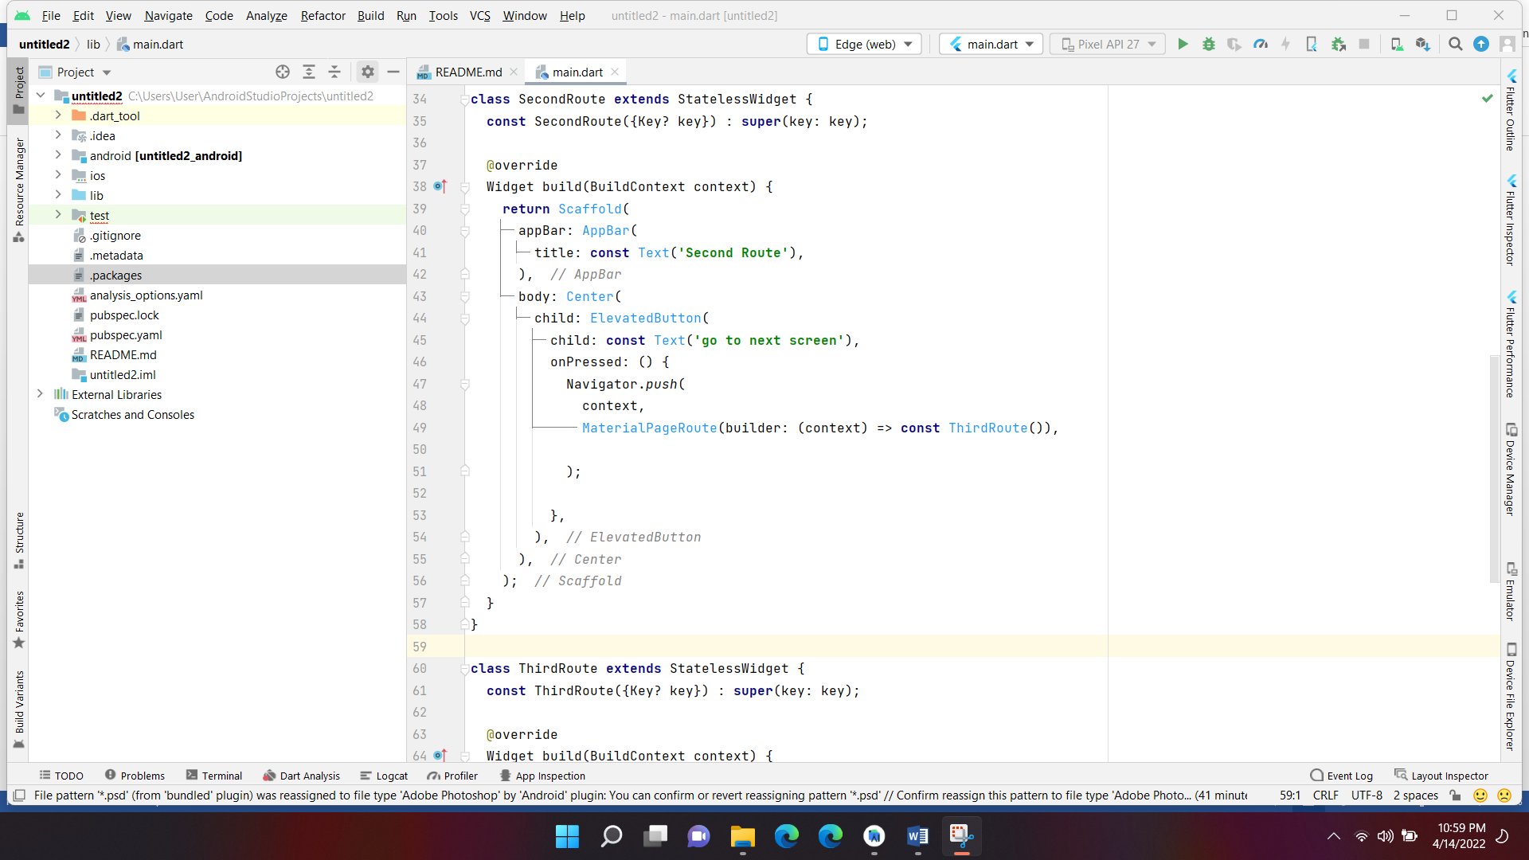

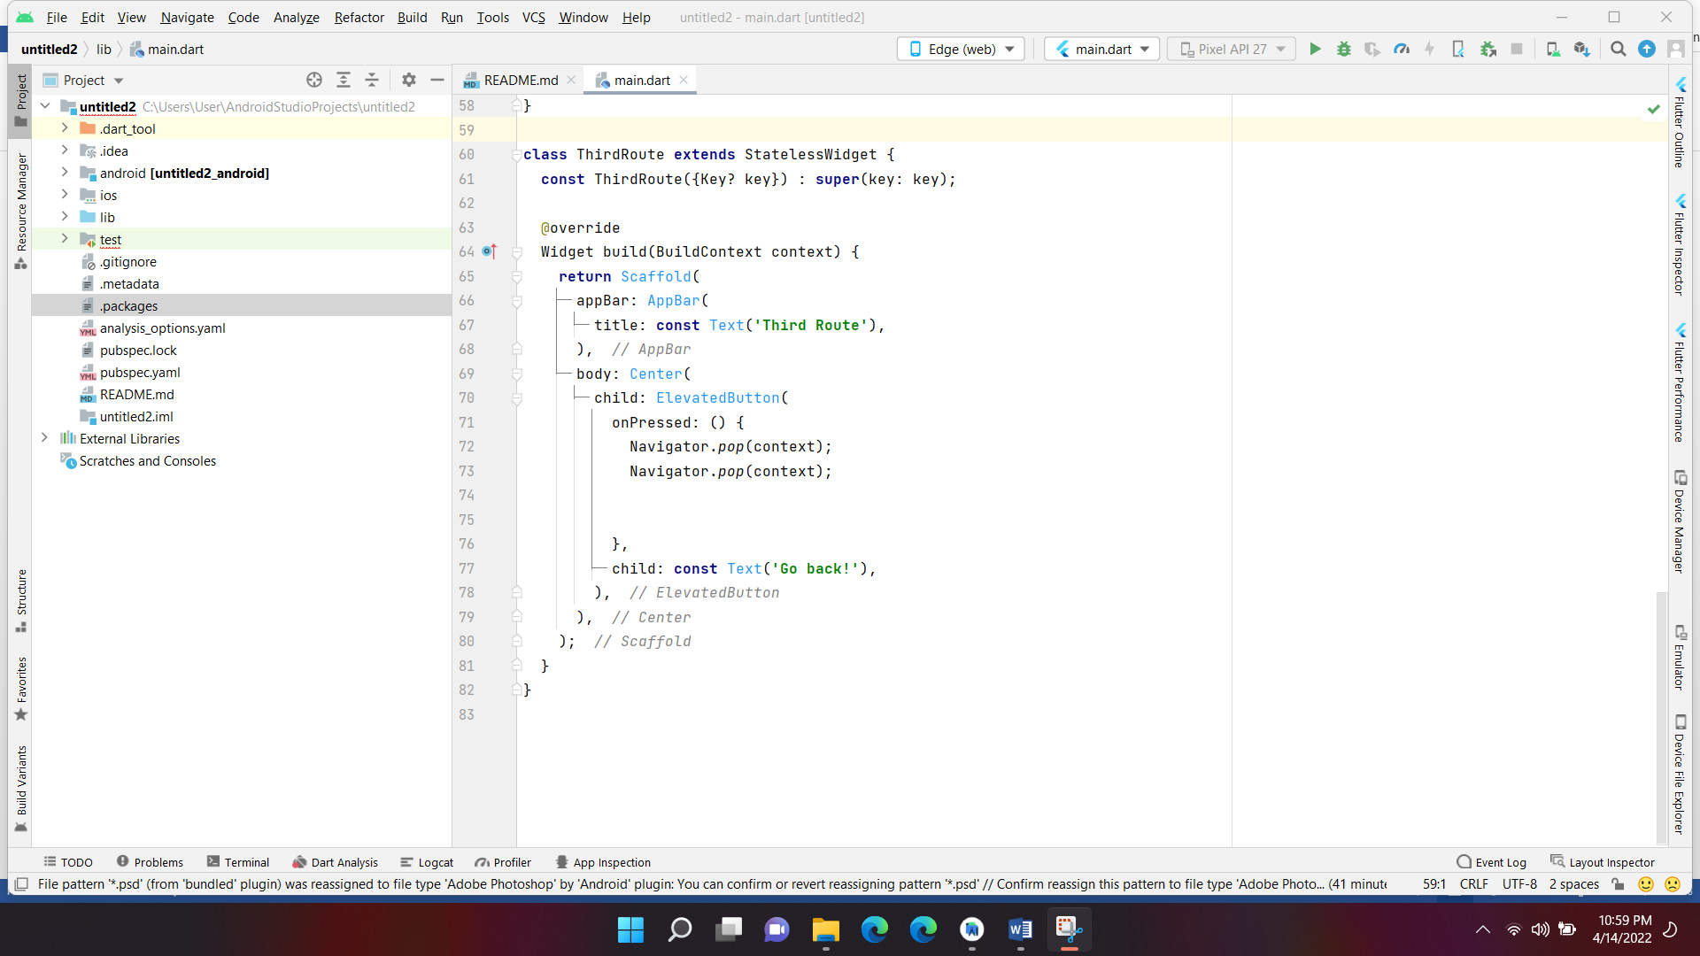

**CONCLUSION:**

This is one of the application where the user can navigate easily through push and pop method.